CSSF – BLOG POST

Headline: CareerSource South Florida is making an impact at eMerge Americas yet again!

CareerSource South Florida is proud to have a presence at eMerge Americas for yet another year. We are a public-private partnership that establishes state and federally funded workforce development and training policies for Miami-Dade and Monroe Counties. We offer incentives to businesses that are tailored to meet the needs of companies operating in South Florida.

We return to eMerge Americas year after year because we understand that our participation at this event goes hand in hand with our goal of consistently creating IT talent pipelines to meet our emerging tech industry demands.

We are looking forward to continuing to support our community’s IT growth, we do so by providing training and other financial incentives that offset costs when hiring and training new and/or existing employees. These valuable resources are responsive to individual company needs and can provide businesses with a competitive advantage in a global economy.

Whether you need an administrator, project manager or IT support, screening candidates and finding the right combination of skills, experience, and knowledge can be a daunting task. Your time is valuable and could be better spent focused on your business goals. The professionals at CareerSource South Florida can save you time and money by helping you achieve success through qualified talent.

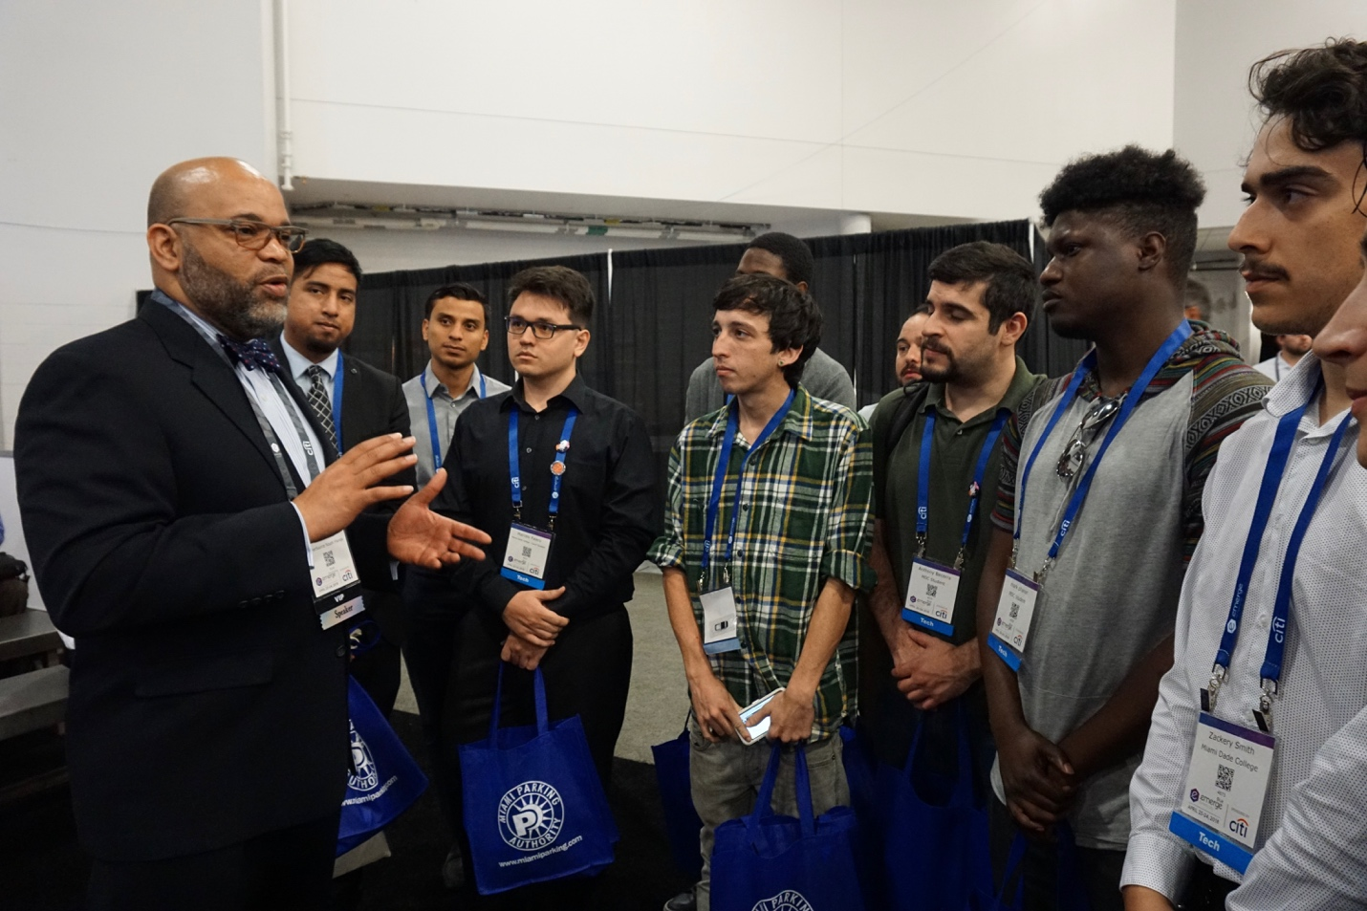

Do you have a vacancy you need to fill? Get started today. (www.careersourcesfl.com/business-services)

We are excited to greet our IT community, April 29th-30th, 2019 at the Miami Beach Convention Center. Please visit us at BOOTH #523.

Looking forward to seeing how the solutions we have available can benefit your business, see you soon.

CareerSource South Florida is an equal opportunity employer/program. Auxiliary aids and services are available upon request to individuals with disabilities.

